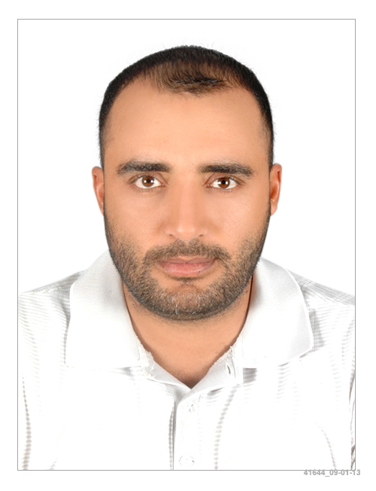Curriculum vitae

**Personal Details**

|  |  |  |
| --- | --- | --- |
| **Name** | : | Mohamed. A .M Saqer |
| **Nationality** | : | Palestinian |
| **Date and Place Of Birth** | : | 10.08.1977 |
| **Marital Status** | : | Married |
| **Present Address** | : | UAE — Abu Dhabi. |
| **Contact Nombers** | : | Mob. 0558554474 / 0527778975 |
| **E– mail** |  | [Mohdsaqer14@yahoo.com](mailto:Mohdsaqer14@yahoo.com) |

Valid UAE driving license

**Objective:**

To provide the construction management and production leadership for the areas of works within the project site. The operation management and control of supervisory staff/ trades and operatives necessary to ensure the effective delivery of production and quality within the areas of work.

**Work Experience:**

**In Brief**

More than **17**years’ experience in building construction works (Palestine& UAE).

**4**years in Palestine and **13**years in UAE

**Job Description:**

* Acting as the main technical adviser on a construction site for subcontractors, Company Manpower including Charge Hands, Labor force and the operations

* Setting out, leveling and surveying the site.

* Checking plans, drawings and quantities for accuracy of calculations;

* Ensuring that all materials used and work performed are as per specifications;

* Overseeing the selection and requisition of materials and plant;

* Managing, monitoring and interpreting the contract design documents supplied by the client or architect;

* Liaising with any consultants, subcontractors, supervisors, planners, Quantity surveyors and the general workforce involved in the project;

* liaising with the local authority (where appropriate to the project) to ensure compliance with local construction regulations and by-laws;

* Liaising with clients and their representatives (architects, engineers and surveyors), including attending regular meetings to keep them informed of progress.

* Day-to-day management of the site, including supervising and monitoring the site labor force and the work of any subcontractors.

* Planning the work and efficiently organizing the plant and site facilities in order to meet agreed deadlines.

* Overseeing quality control and health and safety matters on site.

* Resolving any unexpected technical difficulties and other problems that may arise.

* Preparing Inspection forms to the consultant and assuring that the work meets the specification and the quality required

* Assure that that the work and material used is as per Estidama PQP requirements.

* Comprehensive study of the project specifications, scope of work, Bill of Quantity (BOQ), drawings, commission of project documents upon receipt of the project (Pre-tender / Post tender stage)

* Issuing LOI and contracts for the Selected Sub Contractor

* Submitting all required Submittals, Suppliers and Shop Drawings to the consultant and making sure that all the works are as per the project specifications.

* Prepare / manage / maintain material and shop drawing register log / updating for projects.

* Prepare / Review and verification of quantities along with PM for material procurement /LPO

* Maintains communication with suppliers, sub-contractors, clients, consultants, Project Control Manager and General Manager and Internal Departments

* Prepare the GIS drawings for ADM

* Preparing the As-Built Drawings before the project handing over.

* Various rendering works by AutoCAD, Photoshop and Revit Architecture.

* Prepare Progress Daily, Weekly and Monthly reports.

* Document Control

* Knowledge in All Authorities Permits, approvals and Handing over

**Projects:**

**2019**

**CATIC THE CHINESE CO.**

Project:. AL AIN DESERT RETREAT& VILLAS

Client : SHEIKH MOHAMMED BIN SUROOR BIN MOHAMMED AL NAHYAN

Pries value : 35.000.000 DH

Position: Construction manager

**2016-2018**

**INJAZ NATIONAL GENERAL ENTERPRISES**

Project:.COURT BUILDING CMW-15124-C001

Client : CMW

Pries value : 12.000.000 DH

Position: Project manager

**2013-2016**

**UNITED ENGINEERING CONSTRUCTION (UNEC) LLC.**

Project: AZURE RESIDANCES (B+G+Attic+10+Roof+Mech. Roof) – PALM JUMAIRAH

Consultant : DAR AL HANDASAH.

Client : NAHKEEL

Pries value : 140.000.000 DH

Position: Construction manager

Project: ALSHUAMIKH SCHOOL

Consultant : KEO.

Client : MUSANADA

Pries value : 100.000.000 DH

Position: Construction manager

**2010 – 2013**

**Alpine Bau Deutschland AG, Abu Dhabi Branch**

Project: SEHA Ambulatory Healthcare Centre Project

Consultant: HDP

Client : SAHA

Pries value : 82.000.000 DH

Position: Construction manager

**2009-2011**

**Al Adraaj gen Cont & Maint Co**

Project: Villas

Position: Site Engineer

**2007-2009**

**Al Nobalaa Gen. Cont Co in UAE**

Projects: Villas

Position: Site Engineer

**2006-2007**

**ALRIMAL Co in UAE**

Project: Villas.

Position: Site Engineer

**Educational Qualifications:**

B.S.C– Degree in Civil Engineering, June 2002

Kiev National University of Construction and Architecture

**Professional Soc**ieties: Membership of Palestine Engineers Association since 2002

**Training Courses**: AutoCAD: Learned to draw and develop most kinds of drawings.

STAAD III: (2000) learned analysis of structures and getting.

MS. PROJECT2000: (2002) Learned to do Time schedule.

**Languages:**

Arabic: fluent (Speaking, writing, reading and typing) English: fluent (Speaking, writing, reading and typing) Russian: fluent (Speaking, writing, reading and typing)

**Skills:**

* Excellent knowledge in Legal and Official Terms
* The ability to draw , Read and analyze AutoCAD , Revit architecture
* The ability to use Photoshop, sketch up and 3DsMax.
* Attention to details
* Creative thinking
* Leadership skills

**Computer Skills:**

* Excellent Skills in All MS Office
* Excellent Skills in Autodesk – AutoCAD
* Very Good Skills in Autodesk – Revit Architecture
* Very Good Skills in Autodesk – 3DSMax
* Excellent Skills in Google Sketch up
* Excellent Skills in Adobe Photoshop