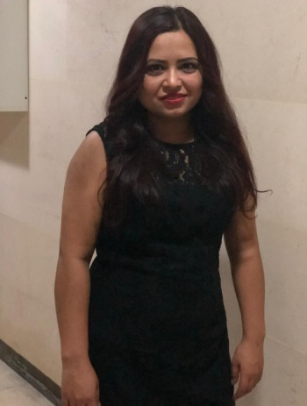

**personal details:**

**Name : samjhana chaulagain**

**Address: alwarqa 2 dubai**

**Email id: anamikachaulagain46@gmail.com**

**Contact no: 0545185638**

**Type of visa : limited**

**Objective:**

To work the changellanging environment of the office, familier of team work to secure a challenging in a reputable organation to expand my learning.

**Key skill and strength**

* Attention to details
* Fast typing
* Accurate data entry
* Ability to work independently
* Editing skills
* Discreation with confidential data
* Time management

**Work experience**

* Worked cargo company in Kathmandu as the position of accounted 1 yrs
* Worked in **UAE** as the position of bus moniter
* Cleaning work

**Knowledge and experance**

* Worked confidentily
* Verified that information is the computer system was up to date and accurate
* Developed and created a more effecitive filling system to accelerated paperwork processing

**Academic qualification**

* **+2** passed from jaya multiple campus
* Slc passed from amar adarsha madhyamik school

**Certificated and traning**

**Computer courses**

* Basic , exel ,miscrosoftword, Microsoft powerpoint
* Graphic design
* Banking courses

**Passport details**

Passport no:09656092

Place of issue:Kathmandu

Date of issue:18Mar,2016

Date of expiry:17Mar,2026

**Personal details**

**Date of birth:25april1991**

**Nationality: nepali**

**Religion: hindu**

**Language: nepali,English and hindi**

**Matural status : married**

**Contact no :0545185638**