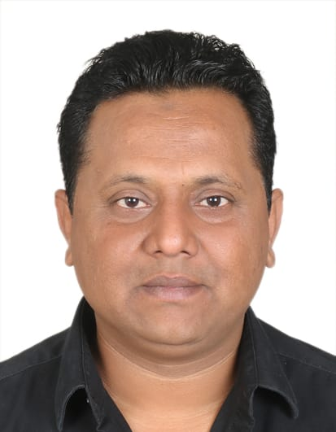**MOHAMMED ARIF**

**Dubai, United Arab Emirates**

[**mohammedarif2309@gmail.com**](mailto:mohammedarif2309@gmail.com)

**Visit visa valid up to 25/02/2020**

**+971525713223**

**+971525434140**

I am a **Graduate with 6+ year Experience in GCC (UAE AND KSA)** overall 10+ years experience; Work with different field in previous companies.

**COORDINATOR/PURCHASE/BACK OFFICE/**

I would like to work for an organization that would offer me an opportunity to develop my competencies in my fields. I shall strive to excel in my field and constantly upgrade myself, keeping in pace with the rapid changes, having acquired the required the requisite skills and through understanding of the business.

**TARGET JOB TITLE**

**Back Office Assistant/ Coordinator**

**PRIMARY SKILS**

1. Computer: MS Office Applications
2. Diploma in computer Hardware
3. Language known: English, Urdu and Hindi
4. Commanding and Monitoring Qualities& Activities.
5. Excellent communication and interpersonal skills,
6. Experience of working with multinationals and multi-cultural environment.

**WORK EXPERIENCE:-**

**4 years Work Experience For**

**ABDULLA & HAMMAD AL GHURAIR INVESTMENT GROUP OF COMPANIES**

## MIDDLE EAST INSULATION -DUBAI

## PRODUCTION & PROJECT COORDINATOR/ADMIN ASSISTANT

* Provides Administrative and Secretarial support as a primary responsibility.
* Establishes, organizes and maintains files. Preparing correspondence, maintain all employees’ personal files.
* Maintaining of all Employees’ Leave Applications and Rejoining.
* Preparing and processing the documents for Employment and other Related Works.
* Distribute all incoming and outgoing documents as per distribution matrix assigned by Managers.
* Controlling all personal mails and maintain log for incoming & outgoing mails.
* Monitoring Daily attendance of workers.
* Preparing daily working hrs sheet of workers.
* Preparing weekly & monthly report to submit.
* Daily manpower allocation, arranging labour as per department requirements.
* Maintaining leave records and monitoring the delay and recommended for further action.
* Employee’s performance report to manager.
* Receive the leave application from labour.
* Review and arranging all paper work.
* Prepares purchase requisition for monthly need stationary items.
* Coordination between labours and admin.
* Keeping on lookout for any unsafe behaviour or break in regulation.
* Inspection of labour camp to make sure safety
* Communicate with all other department of organization

**Work 3 years for**

**ENTIAZ FOODS. - Riyadh**

**Office Assistant/Purchase & Store Supervisor**

* Performed routine administrative duties (i.e. Photocopying, Scanning, Faxing, Filing E-mailing, answering phone calls
* Keying of data in excel/access database
* Handled Procurements tasks.
* Sorts, Organizes and Catalogues documents in a filing system that will be easily accessible and well safeguarded.
* Memos, Preparing Documents for the Client and Maintain all Project Related Files, Document Handling, Document Copying, Book Keeping, Records Maintaining
* Handling of entire store activity
* Material planning and purchase requisition
* Preparing the list of fast moving/Slow moving items and not unusable materials.
* Preparing time sheet of the all staff and labour

**BACK OFFICE ASSISTANT CUM PURCHASER (2 years)**

**IPE GLOBAL LIMITED (JAIPUR) INDIA (SOCIAL AND ECONOMICAL DEPT)**

**JAIPUR, RAJASTHAN**

**Job Responsibilities:-**

* Establish, Organize and maintain files, Preparing All Employees Files.
* Document Handling, Document Copying, Book keeping, sort by categorize Document.
* Preparing and Processing the Document for Employment, Employee ID, New bank account.
* Log in incoming and outgoing documents.
* Scan all Document, Drawing and for electronic archiving
* Invoice processing
* Vendor management and Vendor processing

**EDUCATION**:-

## Masters of Arts (Previous)

**UNIVERSITY OF RAJASTHAN - Jaipur, Rajasthan June 2005**

## Bachelor of Arts

**University of Rajasthan**

**Jaipur, Rajasthan June 2004**

# **CERTIFICATIONS AND LICENSES**

## Diploma in Computer Basic and Account

**July 2008 to Present**

1. **ADVANCE DIPLOMA IN COMPUTER HARDWARE AND NETWORKING**

**July 2000 to Present**

1. **Saudi ArabDriving licence**

## November 2015 to November 2025

# **PERSONAL DETAIL**

* **Date of Birth 19/06/1981**
* **Nationality INDIAN**
* **Marital Status Married**
* **Visa Type Visit visa for 3 months (25/02/2020)**