**CURRICULUM VITAE**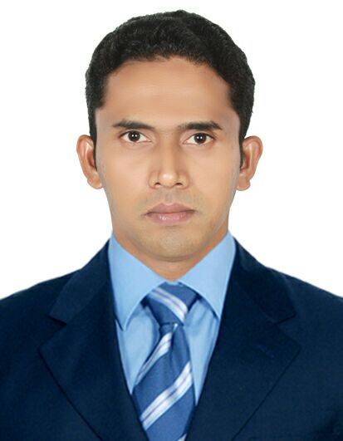

**ABDUL KHADAR KUMER**

Email **:** althafpathoor2013@gmail.com

Phone : 971-559793329

Visa Status : Employment Visa – Active

Current Place: Dubai – Al Qusais.

**Career Objectives.**

**I** am inquiring an organization where a challenging position gives me opportunity to grow with it and to exhibit my abilities & efforts through my experience for the organizational growth along with my better personality development and career as well.

**Personal Details**

Date Of Birth : 09/11/1988

Marital Status : Single

Gender : Male

Religion : Muslim

Nationality : Indian

Fathers Name : Ibrahim

Permanent Address : Kumer House , Pathoor PO

, Manjeswaram , Kasargod, India.

Educational Qualifications : 12th Passed. ( Govt : P U College , Mudipu , Karnataka 2006 )

Computer Knowledge : **Basic.**

Linguistic Skills : **English, Hindi, Tamil , Malayalam , Arabic**

**Key Skills**

Excellent communication & interpersonal skills.

Polite Approach , Obedient & service oriented.

Sense of Responsibility.

Quick Learner & Hard core worker.

**Work Experience**

1. Presently working as Office Boy (for Client & Consultant) in **Delta Al Emirates Contracting LLC Dubai**. **Since June 2013 onwards** .

***Job Responsibilities***

1. To assist site office / consultant secretary / document controller for document scanning & filing process.
2. Maintain pantry service to the consultant / site staff.
3. Maintain a Clean & tidy atmosphere at Office premises / work area.
4. Ensure daily facility status (water, A/c maintenance, food waste movement, pantry items order etc.. )
5. Regular correspondence composing / delivery within the office.
6. Worked As Security Guard at Highland Hospital, Mangalore India. (2009 May - 2012 Apr)

***Job Responsibilities***.

A) Answer telephone calls promptly & efficiently by providing information to routine enquiries or route calls to appropriate section / staff.

B) Perform clerical duties that are necessary to run an organization like vehicle record, visitors Log.

C) Prepare & schedule Meetings.

D) Regular correspondence composing / delivery within the office.

1. Worked As Office Boy at Vimala Plywood’s Cochi , Kerala ( 2008 Feb – 2009 Jan )

**DECLARATION**

**I** hereby declare that the above mentioned particulars are true to best of my knowledge and belief.

**10/10/2017**

**Note :** Character Reference letter will be provided upon demand at the time of interview.