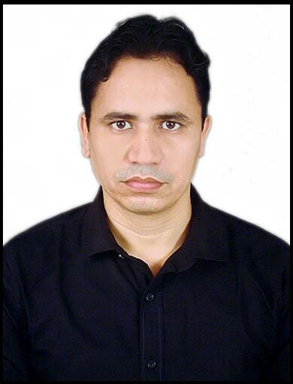
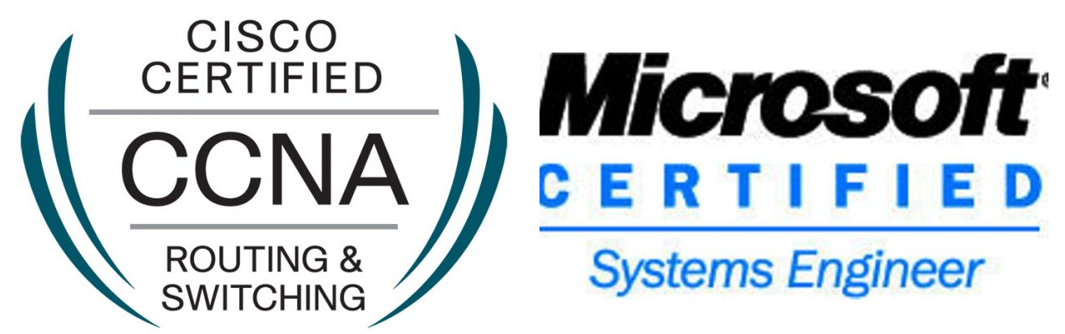
SHADAB AHSAN
Email: ahsan.shadab@gmail.com
Mobile: - +971-588867130
Skype ID: shadab.ahsan
Visa Status: - VISIT VISA

Career Objectives:

Results oriented, diversified IT professional with around 9 years of experience in the industry of Information Technology. To develop a career as a System Engineer in an energetic work environment that can make use of my proven abilities in system engineering and management. Consistently seeking and implementing new and more efficient processes to improve the company IT Operations. Team player and an innovator who is willing to go the extra mile to achieve company objectives, self-motivated and a quick learner, constantly studying and training to keep abreast of new technologies. I have strong technical skills and employment ability which should assist me in my job. Extensive knowledge of hardware and software.

Experience Profile: Total Experience 9 yrs

- COMPANY : Alpha Data LLC
- DESIGNATION : IT Support Engineer
- DURATION : October 2017 To October 2019
- ADDRESS : Mazaya Business Avenue, BBI Tower, JLT
- I was deputed in Dubai Truism near World Trade Centre Also work with different client site of Alpha data at Mashreq Bank, Unilever, Richemount, Switzer, and Marsk Line as an IT support Engineer. Worked with ways InfoTech Client Wipro InfoTech, Dubai. (July 2014 – September 2017), as an IT Engineer. Worked with various client projects like Dubal (Dubai Aluminum), National Bank of Fujairah, AJMAN BANK, FIRST GULF BANK, Emirates NBD BANK, Emaar Square and ROAD AND TRANSPORT AUTHOURITY (RTA), DynaTrade Automation Group, SANOFI located in JLT as an IT support Engineer.
- Involved in Desktop Migration Projects: XP/Win7 to Windows 10 for Approximately 800 users.

Responsibilities during work were:
- Responsible for Windows 10 Deployment done through SCCM for more than 1000 workstations.
- Experience in mailbox movement and good knowledge about the roles in exchange servers.
- Supported all remote offices and home-based users and vessels using windows RDP & SCCM.
- Support for users related to all IT infrastructure/equipment and business specific applications.
- Deal with Vendors, Work with Dell and Microsoft for Escalated Technical Issues
- Handling Asset Inventory of Blackberry, Data card, Hardware and Software.
- Using Active Directory to create & delete domain accounts and to reset domain passwords, to unlock domain accounts and to provide access rights to the users.
- Handling CCTV backup as per client requirement
- Work in Microsoft Outlook, MS-office, and Network Printer. Windows 7/10 & Mac OS environments, Projectors, cameras.
- Configuring and Troubleshooting in LAN network & installation of Network printer.

- COMPANY : Ways Infotech LLC Dubai
- DESIGNATION : IT Support Engineer
- DURATION : July 2014 to September 2017

Responsibilities during work were:
- Installing, Configuring Outlook User profile, Local and Network printers.
- Involved in migration project upgrading from Windows XP to Windows 7, Internal Laptop Support.
- Presently working in HP as Laptop Service & Support Engineering.
- Hands on experience of HP Desktop and Laptops issues with hardware and OS related problems.
- Diagnosing and troubleshooting Laptop and desktop issues.
- Hardware installation, testing, cleaning, troubleshooting, repair and maintenance.
- Excellent project, technical, presentation and problem management skills.
- Using Service Now ticketing tool System at FGB client Site.
- NAC Activity in First Gulf bank updates the Avaya Phone and check setting in pc.
- Apply to NAC all PC’s and phone with the help of Network team.
- Deploy and configuring PCs, Workstations and Laptops.
- Operating System Installation of Windows XP/VISTA/Windows 7.
- Installation and Raid configuration of Windows server 2003 and 2008.
- Imaging PCs, Workstation and Laptop using Symantec Ghost & Acronics tool.
- Explains the exact cause of problem and provided solutions to it.
- COMPANY : M/s-CEGELEC
- DESIGNATION : IT Support Engineer
- DURATION : October 2013 to 6th April 2014

Responsibilities during work were:
- Technical Support Services: Provide technical support via telephone and email requests from internal users for all PC hardware, software and associated peripherals.
- Install and perform minor repairs to hardware, software, and peripheral equipment, as per installation specifications, setting up PC for employee use performing & ensuring proper installation of operating systems, and appropriate software’s.
- Plans network installations by studying customer orders, plans, manuals, and technical specifications.
- Ordering and gathering equipment, supplies, materials, and tools for assessing installation.
- Maintains network by troubleshooting and repairing, testing network back-up procedures, updating documentation.
- Maintains safe work environment by following codes, standards, and legal regulations.
- Maintain to operational procedures and complete appropriate documentation, Take responsibility for tools, and plant and test equipment.
- COMPANY : M/s-Wipro InfoTech
- DESIGNATION : IT Support Engineer
- DURATION : Aug 2010 to Aug 2013
- ADDRESS : NEW DELHI (INDIA)

Responsibilities during work were:
- Complete PC Hardware assembly and maintenance.
- Installation,configuration and troubleshooting of Microsoft client & server Operating systems like Windows XP Professional, Windows 2000 Professional, Windows vista, Windows 7, WINDOWS 2003 server, Windows2008 server.
- Handling various hardware including /IBM/WIPRO/HCL.
- Providing support to various clients located in Delhi & NCR region for the different h/w mainly Wipro, HCL & IBM Servers mainly to the Government clients (National Informatics Centre) and handling customer escalation.
- COMPANY : Sify Technology Limited
- DESIGNATION : Network Support Engineer
- DURATION : Dec 2009-May 2010
- ADDRESS : NEW DELHI (INDIA)

Responsibilities during work were:

- Assisting in resolving Customer Network Related Problems on phone, Remote login and also site visits.
- Troubleshooting of Broadband links on Axxelera and Proxim based products.
- Leased line, ISDN and Wireless broadband troubleshooting.
- Monitoring of POP connectivity and Metro-Ethernet infrastructure through NMS tools.
- Configuring routers for VPN customers. Managing & maintaining wireless network.
- Responsible for designing and implementation of customer’s network infrastructure
- Help negotiate hardware, software, and circuit contracts for customers
- Redesign customer’s office copper and fiber cable plant for scalability
- Configure and implement Remote Access Solution: VPN, ISDN dial up.
- Troubleshooting problems related LAN and WAN connectivity and configurations.
Professional Certifications:
- Microsoft Certified System Engineer (MCSE)
- Cisco Certified Network Associate (CCNA)

TRANNING
- Successfully completed training on MCSE 2003 And CCNA at IACM (Institute of Advance Computing Management), South Extension-1, New Delhi-110049
Educational Qualifications:
- MBA : Information Technology (Karnataka State Open University)
- Bachelor : Bachelor of Science Information Technology (Global Open University)
- Intermediate : Bihar intermediate Education Council from Patna
- Matriculation : Bihar School Examination Board from Patna
Passport Details:

- Passport No : Z2759574
- Date of Issue : 26/03/2014
- Date of Expire : 25/03/2024
- Place of Issue : Patna (Bihar)
- Visa Status : Visit Visa (Valid Till 6th April)

Date………………...
Place ……………… (Md. SHADAB AHSAN)

