nd

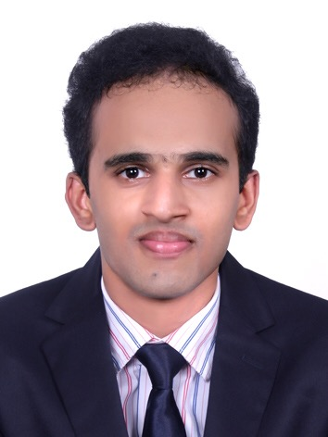

NEBIN SAM VARGHESE

[nebinsamvarghese@gmail.com](mailto:nebinsamsinger@gmail.com)

+917594837581

rr

EDUCATION

Bcom with Aviation &

Hospitality

PERSONAL DETAILS

Age :24

Date of Birth :29/06/1995

Nationality : Indian

Marital Status : Single

Passport No : P6559742

Place of issue : Kollam

Date of issue : 19/04/2017

Date of expiry : 18/04/2027

Address : Princy Bhavan

Anandapally Po Adoor

LANGUAGES KNOWN

* English
* Hindi
* Tamil
* Malayalam

HOBBIES

* Listening to Music
* Singing
* Playing football

**Profile**

**Career Objective**

LE

To build career in a growing organization, where I can get the opportunities

to prove my abilities by accepting challenges

**AREA OF EXPERTISE**

**Strengths**

* Hardworking ,active
* Confident
* willingness to learn and has leadership and communication skills
* Positive attitude
* Good communication

**Skills**

D Good communication skill

Leadership skill

Interpersonal skill

**Achievements**

* National service scheme
* Arts and music executive member in college
* 45 Days Industrial Exposure Training program in Front Office & House keeping Department has been successfully completed in Munnar summer castle

**Educational Qualification**

* Bcom with Aviation & Hospitality [ ICMS INTERNATIONAL KOTTAYAM,MAHATMA GANDHI UNIVERSITY
* Completed plus two [12th] NATIONAL INSTITUTE OF OPEN SCHOOL [2016]
* Completed 10th SSLC From [ DR.C.T EAPEN MEMORIAL ST THOMAS VHSS PANNIVIZHA] [2011

**Reference**

Mrs Zeena Mathew Mr Siju George

Principal of ICMS International,Manarcad General Manager

[principal@icmsinternational.com](mailto:principal@icmsinternational.com) Munnar Summer Castle

Ph- 9526024999 Ph- 8129527111

**Declaration**

I hereby declare that all the information given above are true to the best of my Knowledge and belief.

Place

Date **Nebin sam varghese**

TECHINCAL QUILIFICATI