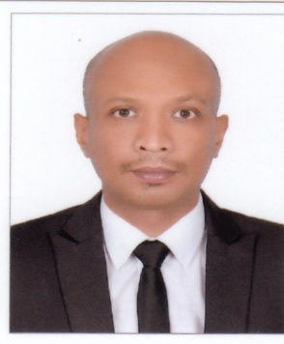SURANGA NIROSHA

🕿  **+971-509047960**

**e-mail : surangatitans@gmail.com**

**Nationality : Sri lankan**

**CAREER OBJECTIVE:**

**To secure a position in the organization that offers challenge and opportunity for my career development and at the same time serves the organization to the best of my capabilities.**

**PERSONAL PROFILE:**

* **Hardworking and dedicated.**
* **Sincere and result oriented.**
* **Can work under pressure with time bound performance.**
* **Easy adaptability to situations.**
* **Good communication and analytical skills**.

**WORKING EXPERIENCE:**

* **Worked as a “ helper for period of three (3)years at GISCO (GULF INDUSRTRIAL SERVICES )Company**

**Abu Dhabi, UAE.**

* **Worked as an Office worker for period of three (3) Years at WORLD WIDE PROJECT Dubai UAE.**
* **Worked as a car gills food city for two years sales boy in Sri Lanka.**
* **Holder of driving license in Sri Lanka**

**EDUCATIONAL ATTAINMENT:**

* **E.C.G O/L**
* **E.C.G A/L**

**PERSONAL SKILLS AND COMPETENCES**

* **Good personal presentation skills.**
* **To be friendly, polite and helpful.**
* **To be patient and diplomatic when dealing with complaints.**
* **Flexibility and reliability, with a willingness to work weekends and evenings.**
* **Good memory, excellent communication skills.**

**PERSONAL DETAILS:**

**Date of Birth : 02/02/1982**

**Nationality : Sri Lankan**

**Gender : Male**

**Religion : Buddhist**

**Marital Status : Single**

**Visa Status : Visit Visa**

**Language : English and Hindi**

**Passport No : N5494343**

**DECLARATION:**

***I do hereby declare that all the above information furnished by me are true and correct to the best of my knowledge.***

SURANGA NIROSHA

SIGNATURE