**MANISHA MANOJ** 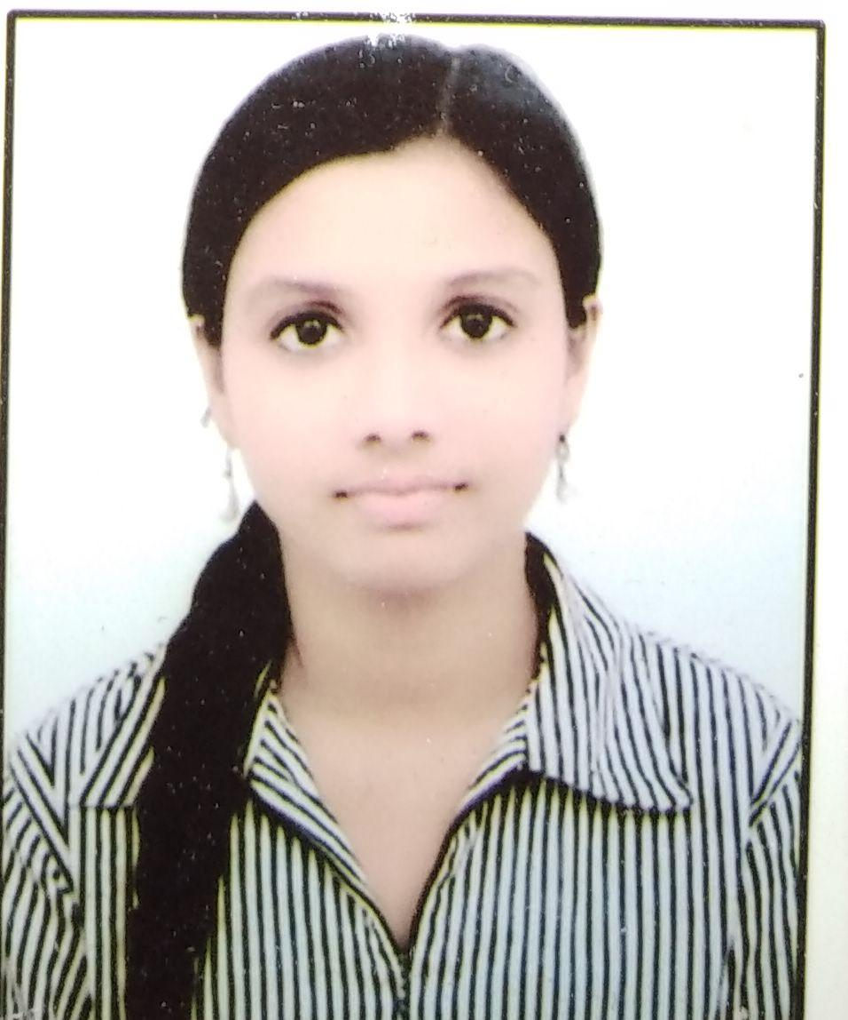

552,Group-3, Janata flats

Hastsal, Uttamnagar

New Delhi 110059

Mobile No. : 9971964533, 9958433041

E-Mail :manishamanoj24@gmail.com

**OBJECTIVE**

I want to be a part of the success of an organization in an environment of growth and excellence

**ACADEMIC QUALIFICATION**

* Pursuing B.A.(Programme) 1st Year from Delhi University
* 12th from CBSE in 2017
* 10th from CBSE in 2015

**PROFESSIONAL QUALIFICATION**

* Pursuing One Year Diploma in Office Management from Institute for Office Management, New Delhi YMCA.

**Course Content**

* Computer Application(MS-Word, MS- Excel, HTML, MS-PowerPoint, MS-Outlook, MS-Access, Tally)
* Business English Communication
* Office Management
* Communication Lab.
* Functional English
* Typewritting
* Shorthand

**Basic Knowledge of**

* Tally
* C++

**Presentations on**

* Indian Classical Dance
* Professional skills
* Multiprocessing

**INTERNSHIP**

* Undergone 15 days' Internship with Ahuja Builders from 15th June 2018 to 31st  June 2018.

**STRENGTHS**

* Hard working
* Flexible

**INTEREST**

* Dancing
* Listening music

**PERSONAL PROFILE**

* Date of Birth : 24th October 1999
* Father’s Name. : Mr.Manoj Kumar
* Languages Known : Hindi, English, Malayalam

**DATE:**   **(MANISHA MANOJ )**