***Curriculum vitae***

***Of***

***Chandra niraula***

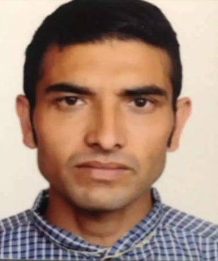***Wall painter & Supervisor***

***Chandra Bahadur Niraula***

***Deira, Dubai***

Contact No.: 0507495296

Painter Job Purpose:

*Responsible for mixing paints, matching colours, preparing surfaces, and applying paint to these surfaces. May perform touch-ups or coordinate large painting projects related to the construction industry.*

Painter Job Duties:

* Preparing painting surfaces by washing walls, repairing holes, or removing old paint
* Mixing, matching, and applying paints and other finishes to various surfaces
* Providing decorative and faux finishes as the project requires
* Handling planning and prep work in an efficient manner
* Preparing the surrounding area by covering with cloth or plastic to prevent messes
* Moving furniture and equipment as necessary to reach the entire surface of the project
* Calculating the amount of materials and time required for said project
* Removing fixtures such as door knobs and light switch covers
* Taping off areas as needed
* Choosing and purchasing paint, brushes, and other supplies from vendors
* Quoting and negotiating job prices
* Cleaning up supplies and replacing fixtures when project is complete.
* Communicating with clients to ensure they're getting the look they're hoping for

***Carrier history:***

Worked as a wall painter in QATARfor the period between (20/12/2017 to 19/12/1019).

* Date of birth :19 NOV 1980
* Passport number :07836789
* Marital Status :Married
* Religion :Hindu
* Known language :Arabic, Hindi, English, Nepali
* Educational Qualification : 10th  passed in 2001

***Strength:***

* Self motivated, clever and learn stuff very fast.
* The ability to work quickly, accurately and pay attentions to details.
* Understanding , ability to work under high pressure, patience and confidence

***Reference available upon the request;***

I, Chandra Bahadur Niraula hereby declare that all the details provided herein are true to all my knowledge and beliefs.

**Chandra Bahadur Niraula**