**JASEELA.A** 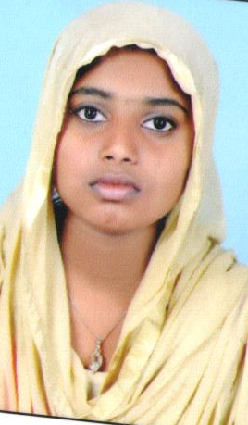

**ARAKKA PHONE: 9645183794**

**KAMBALAKKAD.P.O, Email:jasijaseela97@gmail.com**

**KALPETTA**

**WAYANAD,**

**KERALA, 6706456**

**CAREER OBJECTIVE**

To learn and grow up in my career and to perform at my best in whatever role I am positioned, which suits my present skills and caliber and work towards customer delight which will help in achieving the organizational goals

**ACADEMIC QUALIFICATION**

|  |  |  |  |  |
| --- | --- | --- | --- | --- |
| COURSE | INSTITUTION | BOARD\  UNIVERSITY | YEAR OF  PASSIGN | PERCENTAGE\  CGPA |
| PLUS TWO | ANSARIYA COLLEGE KAMBALAKKAD | KERALA STATE  BOARD | 2015 |  |
| S.S.L.C | G.H.S.PERIYA | KERELA STATE  BOARD | 2013 |  |

**TECHNICAL SKILL**

* Handing email
* MS excel
* MS word

**SHORT TERM COURSES ATENDED**

* IT-ITES: SECTOR SKILL COUNCIL CERTIFIED COURSE
  + - * + **Over view of BPO**
        + **voice and Nonvoice**
        + **Time management**
        + **knowledge about a problem solving**
        + **escalation matrix**
        + **CRM ( Customer Relationship Management)**
        + **Handiling of Ticket**
        + **Importance of feedback**
        + **soft skill**

**PERSONAL DETAILS**

Age : 18

Date of birth : 29.01.1997

Marital status : Single

Language proficiency : Malayalam, English and Hindi

Hobbies : Drawing, cooking and watching TV

**DECLARATION**

I hereby declare that all the above given information is correct to the best of my Knowledge. If given the opportunity, I will give my best to achieve the object the organization.

Place: Kambalakkad Jaseela AM

Date: Signature